**Skimming:**

**Age: 01-01-01 , 01-01-02, 01-01-03 =   ( 01-02-01 - Minor),  (02-01-01 - Major)**

**If you package any rule all the versions will be packaged.**

**If you want to drop the rules from previous/Lower versions then we can go with skimming.**

**Skimming Def: It is the Process of Copying all the rules from lower ruleset version into next highest version by eliminating duplicates.**

**There are 2 types of skimming:**

**Major Skimming**

**Minor Skimming**

**Ex1: 01-01-05  ( Current Version)**

**Minor : 01-02-01**

**Major:  02-01-01**

**Ex2: 01-04-05**

**Minor: 01-05-01**

**Major: 02-01-01**

**Major or Minor depend upon our business requirement.**

**Open Ruleset Form:**

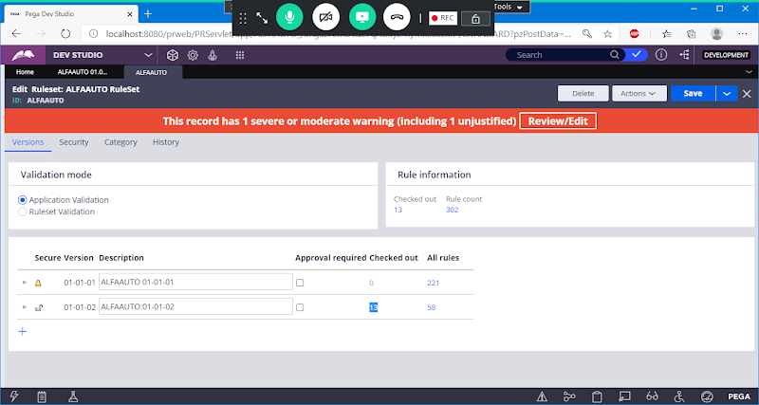

**Now We need to Check in all the Checkout Rules**

**Select Bulk Actions from Private Menu:**

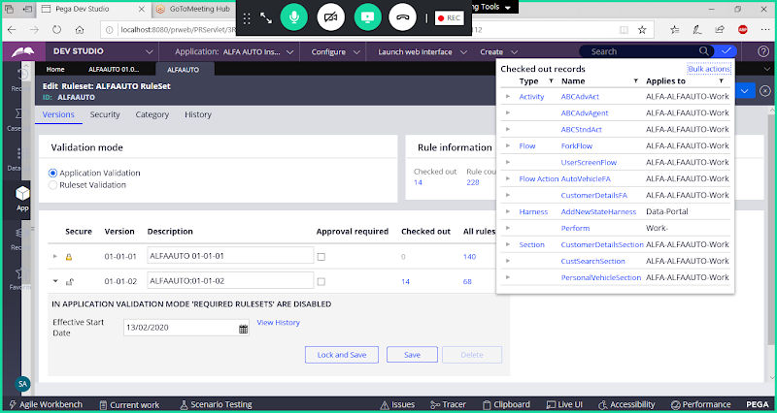

**Click on Bulk Actions**

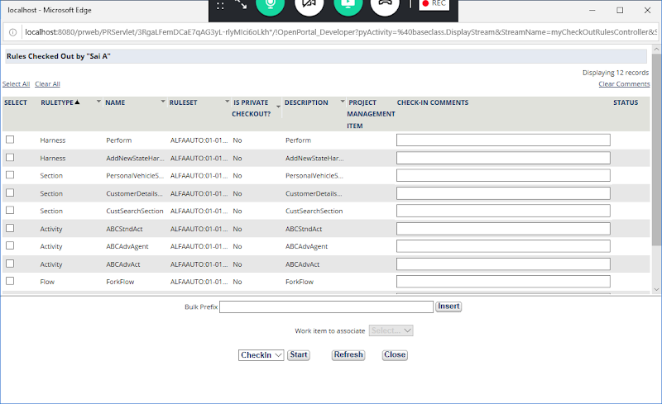

**Select All Checkout Rules, add prefix & Start Check in**

**Add Bulk Prefix & Click on Insert**

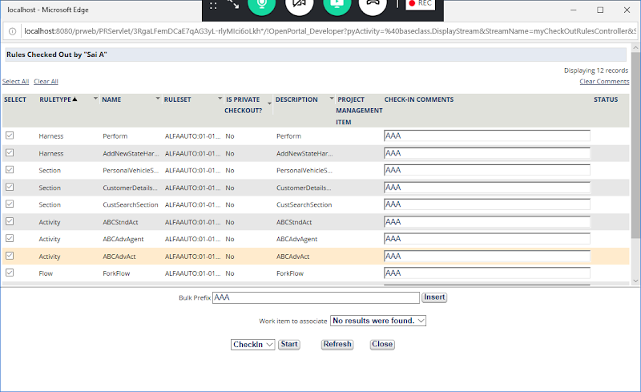

**Now Click Start Next to Check in**

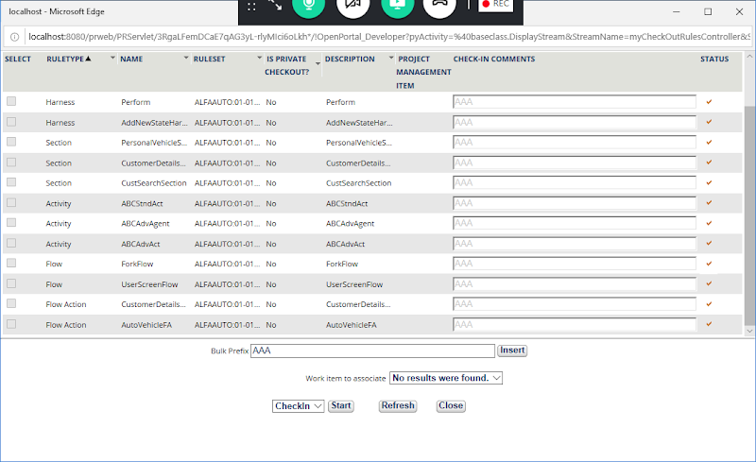

**After Check in All the Records you can close the WIndow**

**Close**

**Now Open your Ruleset Form & Lock your Ruleset version: 01-01-02**

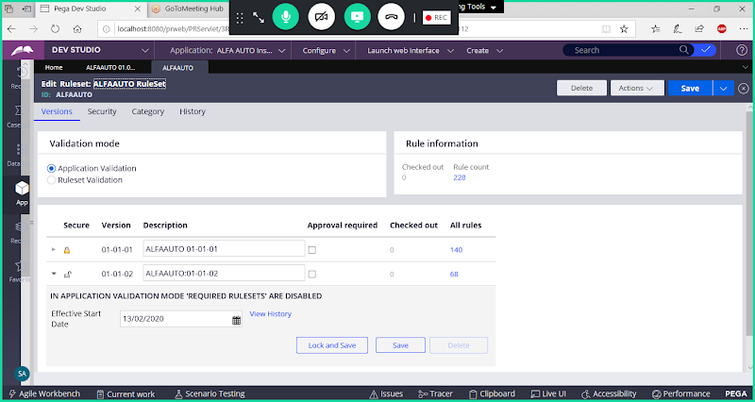

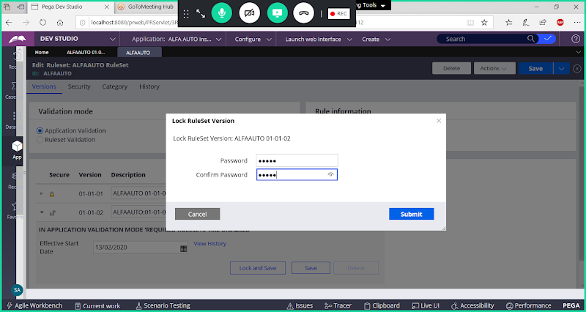

**Submit**

**Save Ruleset**

**Perform Minor Skimming for the current ruleset Version: 01-01-02**

**Open skimming Wizard:**

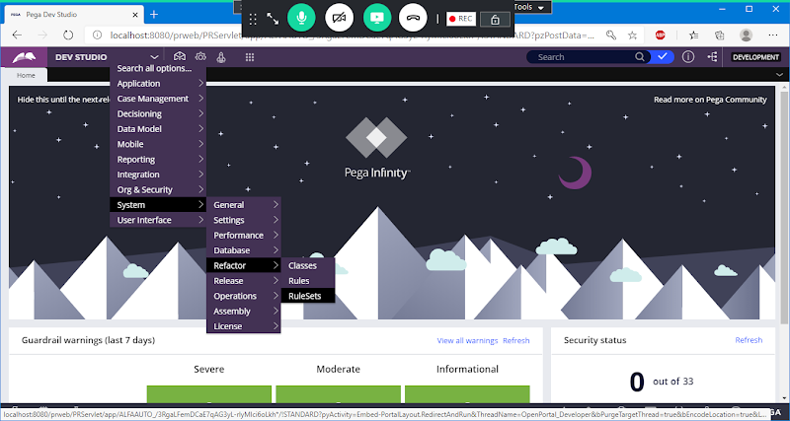

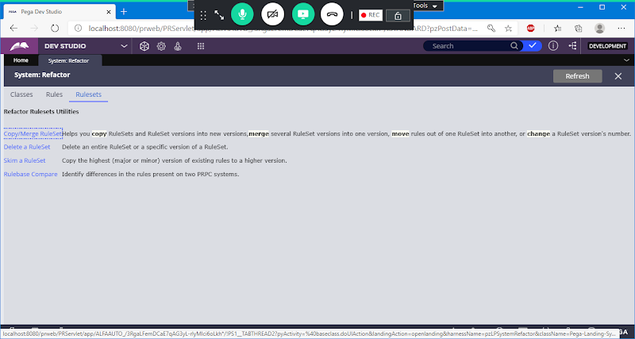

**Click on Skim a Ruleset**

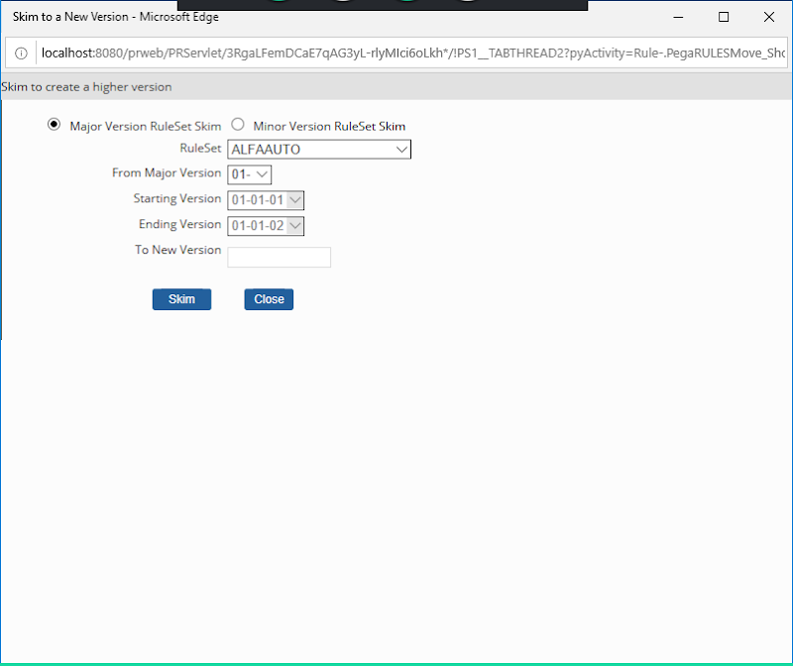

**Select Minor Version Ruleset Skim**

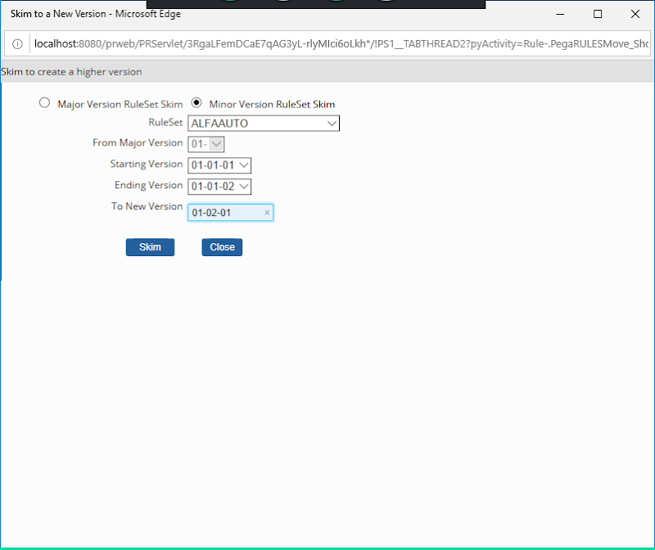

**Click on Skim**

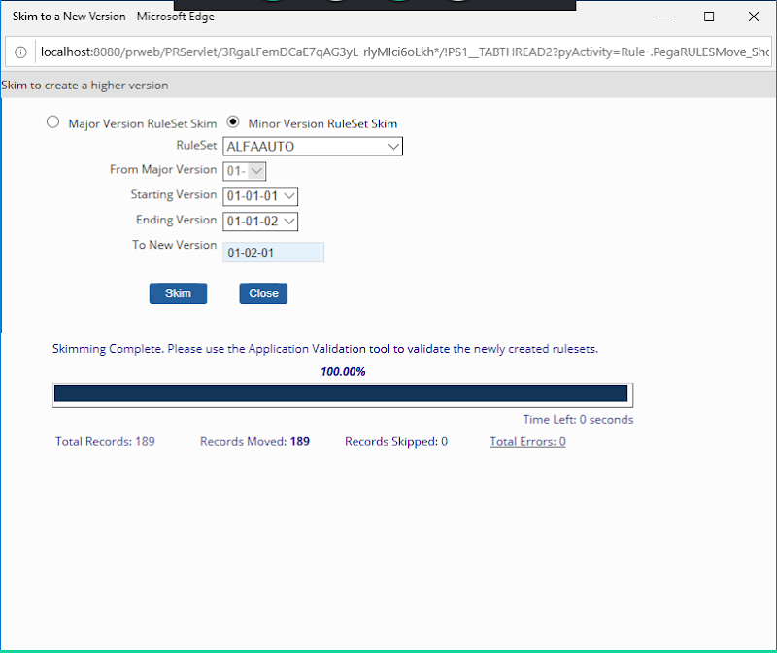

**Click on Close**

**Now Open your Ruleset form:**

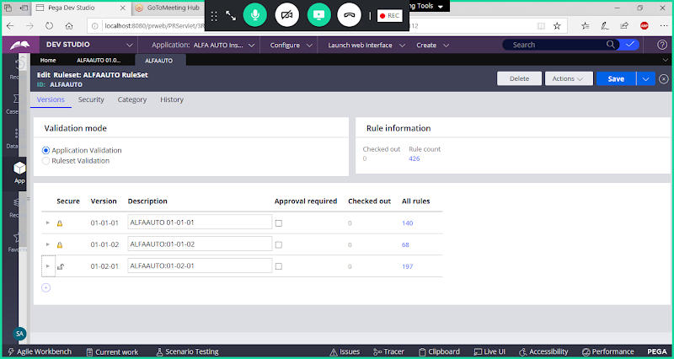

**Now if you try to add any New Rule it will not show your Ruleset Version ( 01-02-01)**

**Instead It will Show :** **ALFAAUTOInt:01-01-01**

**After Skimming the Minor Version is changed to 01-02, So Your Ruleset Version 01-02 is not identified by the server.**

**So, we have to Change our Ruleset Version from ALFAAUTO:01-01to ALFAAUTO:01-02**

**Open Application Definition:**

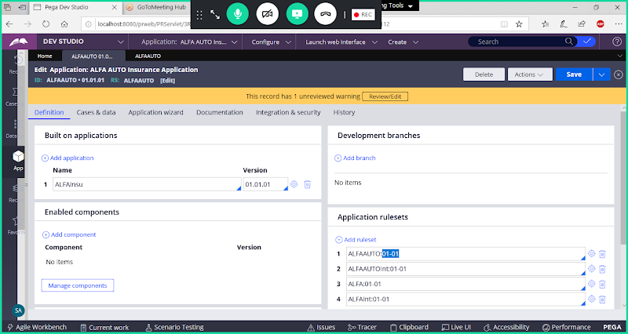

**Change RuleSet Version to : ALFAAUTO:01-02**

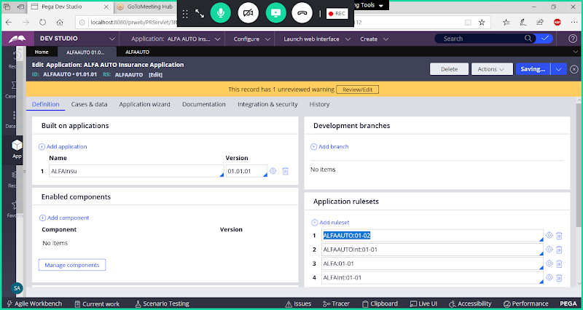

**Save Application Definition**

**========**